**Assignment 1**

**Operating System**

**Name:** Etcherla Sai Manoj **Mis. No:** 112015044 **Branch:** CSE

**1. Implementation of First Come First Serve Scheduling Algorithm**

**Case 1:**  
Input: Processes and their Burst time (Minimum No. of Process 4)  
Output: Average waiting time, Average Turnaround Time

**Code:**

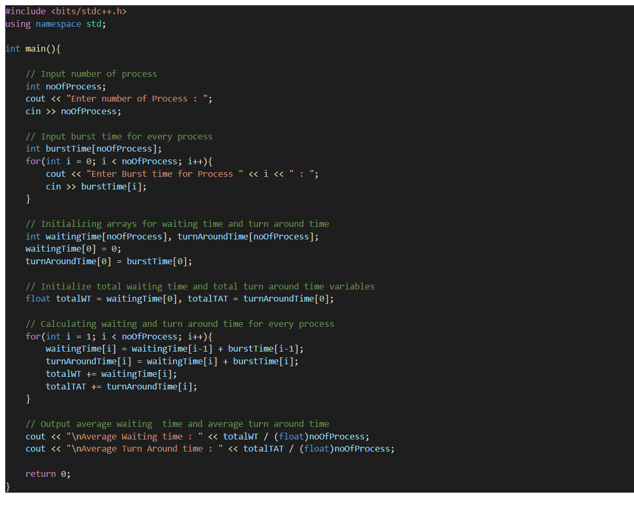

**Output:**

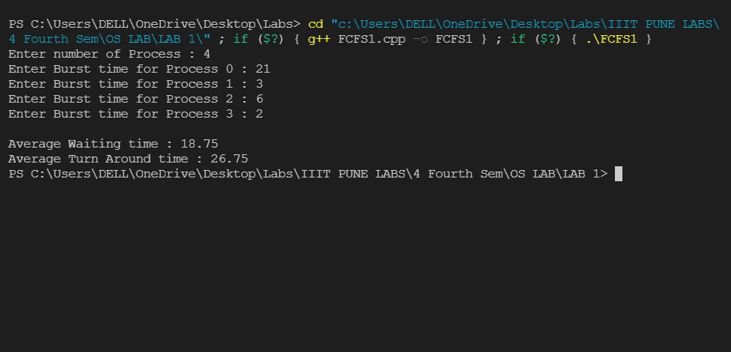

**Case 2:**Input: Processes, their Burst time, and Arrival time (Minimum No. of Process 4)  
Output: Average waiting time, Average Turnaround Time

**Code:**

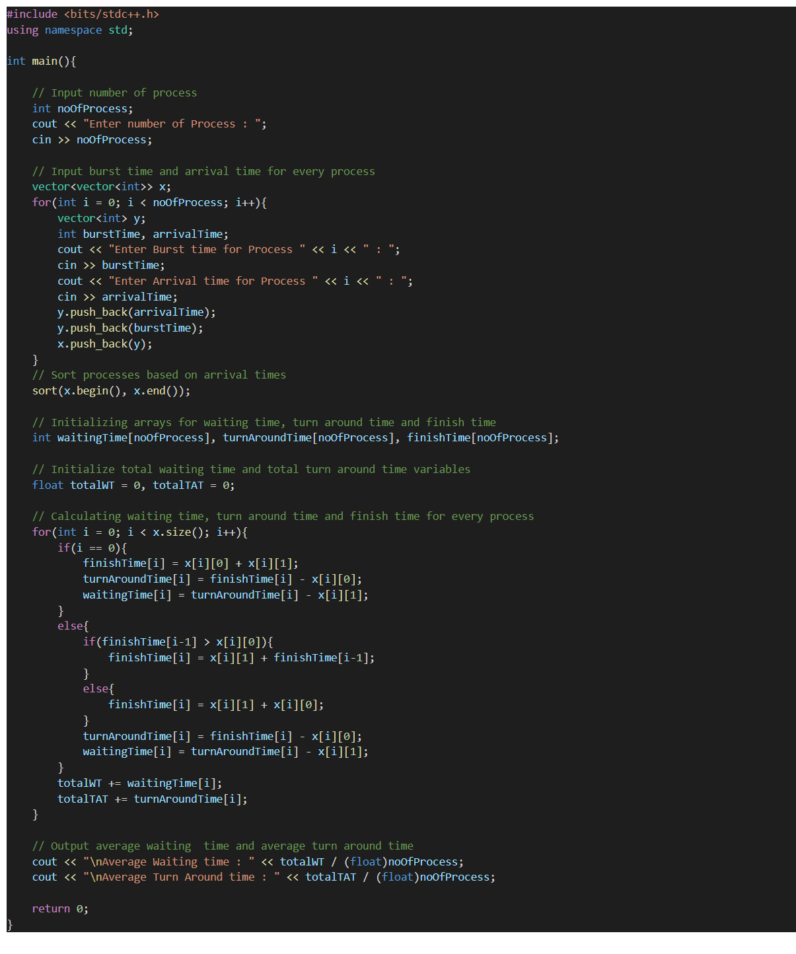

**Output:**

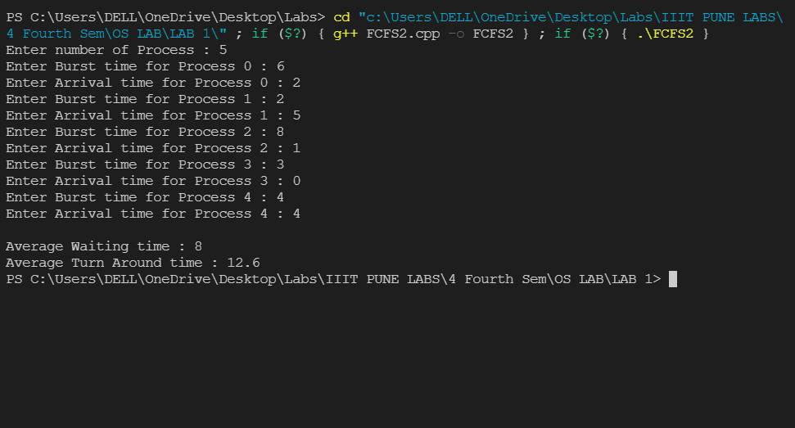

**2. Implementation of SJF Scheduling Algorithm.**  
(Minimum No. of Process 4)  
  
**Case 1: Non-Preemptive**  
Input: Processes, Burst time, and Arrival time are given as input (Minimum No. of Process 4)  
Output: Average waiting time, Average Turnaround Time

**Code:**

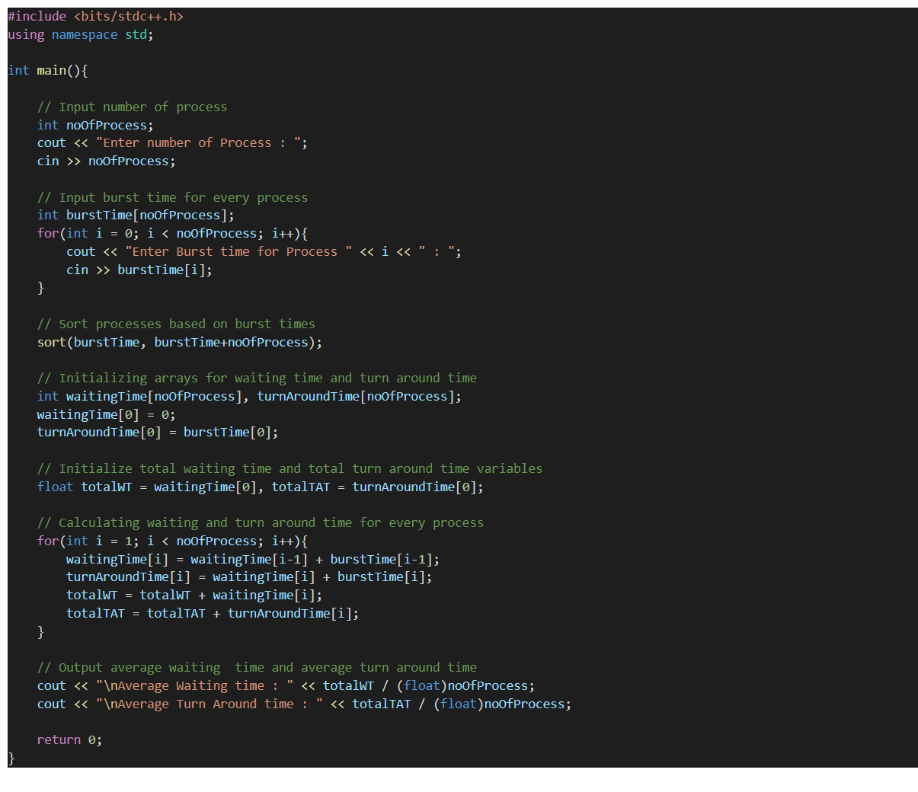

**Output:**

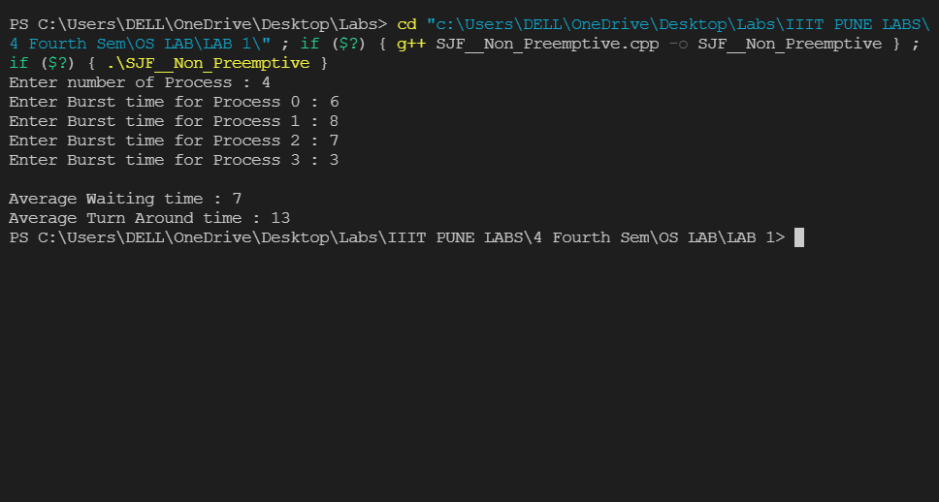

**Case 2:** **Preemptive.**  
Input: Processes, Burst time, and Arrival time are given as input (Minimum No. of Process 4)  
Output: Average waiting time, Average Turnaround Time

**Code:**

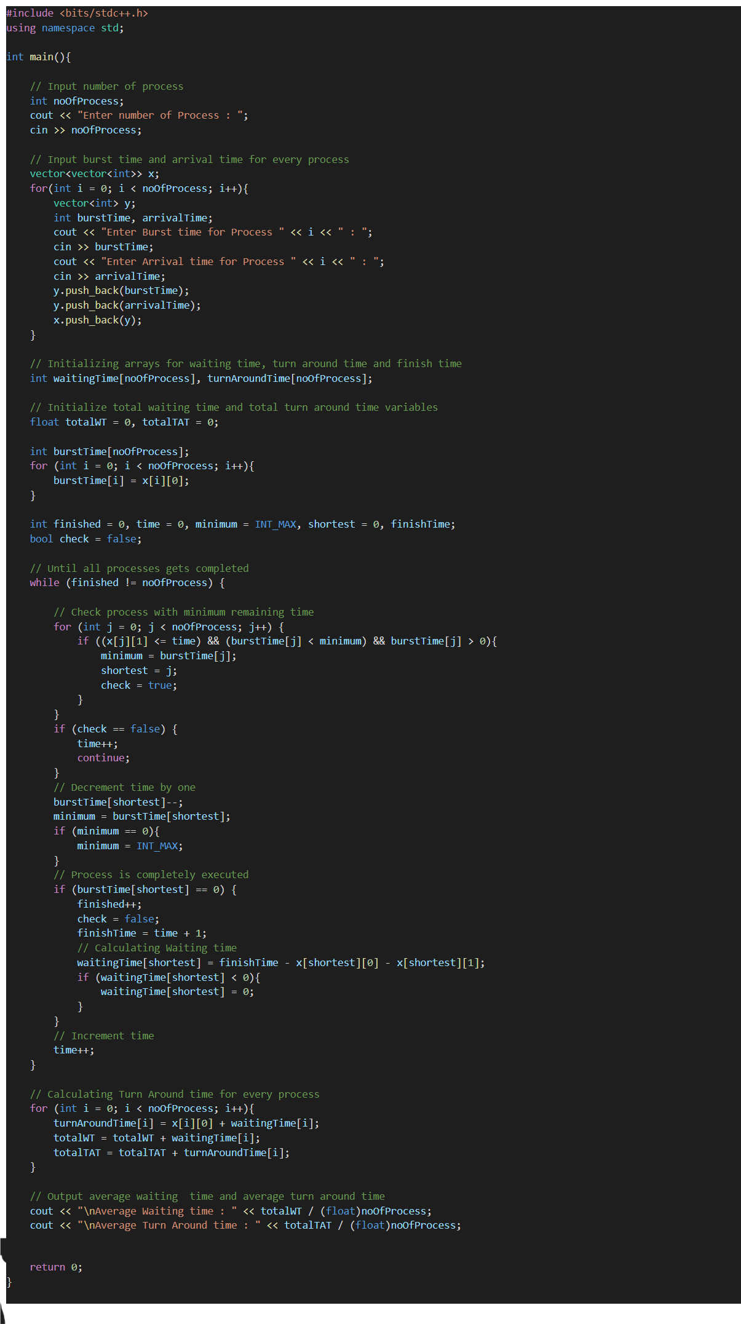

**Output:**

